# Total Road Incident Cost Calculator

Team

Anmol Shrestha

Connor Fox

Ryan Sadar

Emey Long

<Copyright>

Table of Contents

**Total Road Incident Cost Calculator** **1**

Figure: 12 Sequence Diagram 4

**1.0 Introduction** **5**

1.1 System Overview 5

1.2 Audience Description 6

1.3 Applicability Statement 7

1.4 Purpose Statement 7

1.5 Document Usage Description 8

**2.0 Software Design Scope** **9**

2.1 Major Software Functions 9

2.2 Major Design Constraints and other Requirements 9

**3.0 Reference Documents** **10**

3.1 Existing Software Documentation 10

3.2 System Documentation 10

3.3 Vendor Documentation 10

3.4 Other Documentation 11

**4.0 User Stories** **12**

4.1 User story Dictionary 12

4.2 Iterative User Story Documents 16

4.2.1 User Story Definitions 16

4.2.2 Flow of Interaction Diagram 23

4.2.3 Unit Testing 23

4.2.4 Integration Test. 23

4.2.5 WireFrames. 23

**5.0 Object-Oriented Design** **29**

5.1 High-Level System Architecture 29

5.2 High-Level Package Diagram and Components 30

5.3 Use Case Analysis 31

Use Cases 31

Use Case 1:Visit Welcome Page 31

Use Case 2:Input Information 32

Use Case 3:Calculate Risk 32

Use Case 4:View Resources 32

Use Case 5:View Research 33

5.4 Domain Model and Class Diagram 34

Relational Tables 35

5.5 Establishment of the Database Objects and Data Access Strategy 36

5.6 Sequence Diagram 36

Figure: 12 Sequence Diagram 37

5.7 Object Dictionary 37

**6.0 Software release report** **39**

6.1 Functional Unit Test Report 39

6.2 System Test Report 43

**7.0 Additional User Interface Design** **43**

**8.0 Glossary** **44**

**9.0 Statement of effort** **45**

Table of Figures

|  |  |
| --- | --- |
| Figure | Page No. |
| Figure:1 High-Level Structural Diagram | 5 |
| Figure: 2 Interactive Diagram | 19 |
| Figure: 3.1 Intro-page Page | 24 |
| Figure: 4.1 Product Information | 25 |
| Figure: 5.1 Insurance & Fleet Information | 26 |
| Figure: 5.2 Grey fleet Information | 27 |
| Figure: 6.1 Calculator Page | 28 |
| Figure:7 System Architecture Diagram | 29 |
| Figure: 8 Package Diagram | 30 |
| Figure: 9 Use Case Model | 31 |
| Figure: 10 Domain Model | 34 |
| Figure 11: Class Diagram | 36 |
| Figure: 12 Sequence Diagram | 37 |

# 

# 1.0 Introduction

### 1.1 System Overview

The National Road Safety Partnership Program (NRSPP) Total Road Incident Cost Calculator was designed to provide the organization with an estimate of the direct and indirect costs associated with a road incident. The calculator helps an organization understand the cost of road incidents relative to:

* Constraints from the client
* The aesthetic and overall design needs to match the existing website.
* The redesigned calculator is to be “User friendly”
* The website needs to contain instructional material, how to use and interact with the calculator.
* Implicit constraints
* The calculator returns correct results based on the given information
* How the existing database is being used will be maintained
* Anonymously collected results from the calculator used to collate a large quantity of incident data from different industries

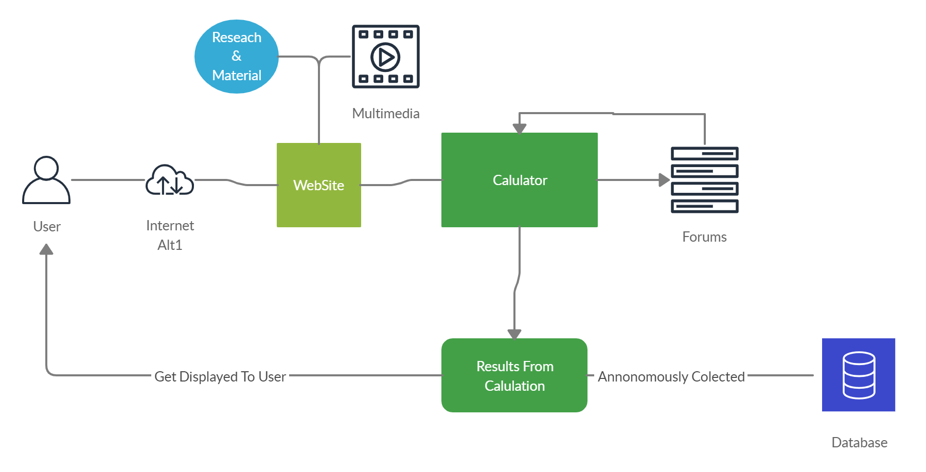

Figure:1 High-Level Structural Diagram

<https://www.nrspp.org.au/resources/fact-sheet-total-road-incident-cost-calculator/>

### 1.2 Audience Description

The calculator recognises the differences in operations and business structure across different sectors. To this end, tailored solutions and calculations are provided for the Manufacturing and Services sector, State and Local Government sector, Health and Emergency Services and Other Community Services and Not-for-Profit organisations.

The total road incident cost calculator is aimed towards a broad audience.

Users of this webpage are only required to know basic computer skills to operate the calculator.

Users of this calculator would include   
  
 **Banks**: banks would want to know the number of fatalities as the people who had the unfortunate incident could have borrowed a loan in the name of their vehicle which means if the vehicle gets totalled it is a loss to the bank as there will be no asset for the bank to seize if the customer is unable to repay the loan.

**Insurance companies** - the insurance companies would be interested in this calculator as it will help them understand the total amount of road fatalities and the costs it creates. With each accident that happens the insurance company undergoes revenue losses as they must pay the insured customer.

**Hospitals** - they must keep updates on how many fatalities occur as it determines how the hospitals must manage their resources such as staff, accommodation etc. The calculator will allow the hospital to be effective in maximising profits by having the necessary resources when required by giving a calculation of the total fatalities.  
When this is done the hospital will not lose revenue as they will be prepared to face the circumstance rather than back down.

**Government** - the government will be using this calculator to determine the number of fatalities to make adjustments to many things :  
How the road safety rules should change   
What needs to be done to prevent fatalities occurring in the future.  
By bringing these mentioned adjustments into action the government can contribute to reducing the costs of losing lives as well as damage to private and public properties hence minimising the risk of future fatalities.

**Car dealerships**: car dealerships would like to know how many car accidents occur in order to calculate how they should bring the shipments and how often they should bring in the shipment to keep up with the demand of motor vehicles in relation to the number of vehicles that are destroyed in the accidents that take place.

<https://www.nrspp.org.au/cost-calculator/>

### 1.3 Applicability Statement

.

The System is designed to run on any system that has a browser and internet access.

### 1.4 Purpose Statement

Total Road Incident Cost Calculator was designed to provide organisations with an estimate of the direct and indirect costs associated with a road incident.

The Major Applications of the website are:

1. The Calculator, where the users can calculate the costs and expenses from a road incident to the user’s company.
2. The Research, a series of resources and information associated with road incident information.
3. The Resources, Instructional videos on how to use the calculator.

### 1.5 Document Usage Description

Describe what each section of the document contains, its intended use, and the relationship between sections. Also, provide any other directions necessary for using the document.

1. **Introduction**  
   A brief introduction to the project domain, its purpose and the intended users
2. **Software Design Scope**  
   This section covers the major functions of the system, its benefits and design constraints
3. **Reference Documents**  
   This section covers the supporting documentation regarding the system design software used and referencing third party software and tools used for developing the system
4. **User stores**  
   This section covers the User Stories of the application, flow of interactions of the system and wireframes.
5. **Object-Oriented Design**This section breaks down the system architecture into smaller subsections so that they are more easily understood.
6. **Software Release Report**This section covers the procedure for usability testing and system testing reports
7. **Additional User Interface Design**  
   This section contains any additional interfaces of the input, output and communication between the user and system.

# 2.0 Software Design Scope

### 2.1 Major Software Functions

Functional redesign of Total Cost Calculator and supporting website content to go alongside it:

* Research
* Guides and Instructional material on how to use Calculator.

Calculator:

* Interpret user imputed data, output functioning results.

System

* Stores User results from calculator in Database.

### 2.2 Major Design Constraints and other Requirements

The Website must maintain a similar Aesthetic as the existing NRSPP website.

Constraints:

* The Calculator must be user friendly, easy to use and understand.
* Improved Clarity

# 3.0 Reference Documents

### 3.1 Existing Software Documentation

Documentation Covering Existing functions of the Calculator.

* Calculations.docx
* Total Incident Cost Calculator.xlsm

### 3.2 System Documentation

There are no system documents applicable as the website is not being embedded in any existing system.

### 3.3 Vendor Documentation

Vender documentation is the various tools, third-party software and frameworks used within the system:

**PHP**

PHP is a server-side scripting language for web development. The PHP code can be mixed with HTML code or can be used in combination with various web frameworks. The Manual for PHP can be found here: <http://www.php.net/manual/en/>

**MySQL**

MySQL is the second most used open-source relational database management system (RDBMS). It is used to create and manage databases, build database structures, backup data, inspect status and work with data records. The Manual can be found here: <http://dev.mysql.com/doc/>

**Bootstrap**

Is a collection of tools and design frameworks used for creating websites using both HTML and CSS.   
<https://getbootstrap.com/docs/3.4/css/>

**JQuery**

Is a small JavaScript library with many uses such as HTML transversal, manipulation and event handling. The API documentation can be found here:

[**https://api.jquery.com/**](https://api.jquery.com/)

### 3.4 Other Documentation

This is the first documentation of this system. There is no other documentation yet made for this system.

# 4.0 User Stories

A user story is a tool used in Agile software development to capture a description of a software feature from an end-user perspective. The user story describes the type of user, what they want and why. ... A user story can be considered a starting point to a conversation that establishes the real product requirement.

The platform Jira is what allowed the agile environment which helped us create the user stories and assign to the team members.

²A user story template often uses the following type of format:

²As a <role>, I want <feature> so that <reason>.

Examples of user stories are:

1. As a user, I want to upload a video so that I can share it with others.

2. As an administrator, I want to approve the video before it is posted so that I can make sure it is appropriate.

<https://www.google.com/search?q=user+story+definition&oq=user+s+tory+def&aqs=chrome.1.69i57j0l7.4597j1j7&sourceid=chrome&ie=UTF-8>

### 4.1 User story Dictionary

\

|  |  |  |  |
| --- | --- | --- | --- |
| Description | Acceptance criteria | Story points | Contributor |
| As a shareholder, I want to see the new interface of the calculator so that I can get a better understanding of the new interface | The new interface was created and tallied with the existing interface and existing user ace was in use as in demand of the client | 5 | Anmol |
| As a stakeholder, I want to see the redesigned landing page, so that I can check the NRSPP’s themes are maintained | The new Landing page was made, and the themes were tallied with the  Websites existing landing page. | 8 | Connor |
| As a user, I would prefer input fields to have specific data types and the maximum characters assigned to it, so that I could predict what to fill in. | Faded instructions were kept on input fields with the information about maximum characters input. | 3 | Anmol |
| As a business analyst, I would like to know the impacts of the calculator to the company so that the company would be able to implement it. | Fact sheets were provided with appropriate links. | 2 | Anmol |
| As an insurance company, I want to know the impacts of costs with a road accident to a company so that company could be more productive | Fact sheets were provided with appropriate links. | 2 | Anmol |
| As a stakeholder, I would like to know the preference of colour, fonts and design for the website so that I could know if it matches our existing design | The themes were provided to the stakeholder and check if it matches the existing design. | 2 | Anmol |
| As a system analyst, I would prefer more research on total incident costs so that company could know the lost revenue or service provision | Fact sheets were provided with appropriate links. | 3 | Anmol |
| As a Road safety worker, I want to have relevant road safety information so that we can be aware of the impact of road incidents | Fact sheets were provided with appropriate links. | 3 | Connor |
| As a clerk, I want to know the purpose of the Calculator, so I know if it's relevant to me | Fact sheets were provided with appropriate links. | 2 | Connor |
| as an Emergency Response Team member, I would like to know how many accidents happen on the roads in the past year so that my company can take necessary measures to treat accident victims | Fact sheets were provided with appropriate links. | 2 | Ryan |
| As a company, I would like to know how many fatalities occur in an accident so that my company could be better prepared when accidents happen and are prepared with the necessary resources to deal with the necessary situation | Fact sheets were provided with appropriate links. | 2 | Ryan |
| As a Business personnel, I want to understand the fact sheet so I can understand if the calculator will be relevant me | Fact sheets were provided with appropriate links. | 2 | Connor |
| As a user, I would like to have a calculation user-friendly page which will be easy to navigate | User could navigate and have their respective calculation without any errors | 2 | Emey |
| As a Stakeholder, I want to see the new interface of the calculator so that I can get a better understanding of the new interface. | Prototype of new interface was displayed as requested | 8 | Connor |
| As a user, I would like to know the data of road accidents in the past few years so that we can measures victims | Fact sheets including statistics of accidents in past years were provided | 2 | Emey |
| As a user, I would like to investigate if the research and resources of the company are visible to know where the resources and research came from to validate if it's effective and relevant. | References were provided and the links to different websites and provided where information was gathered. | 3 | Anmol |
| As a user, I would like to know the resources of the company regarding information so to check if the information is real and valid. | Resources page is directed in the website where various links are attached to see where the information is gathered from. | 2 | Anmol |
| As a user, I would like to read the information so that I can understand the relevance of the calculator and its purpose | Fact sheets of calculator were provided | 2 | Ryan |
| As a manager I would like to be able to see the average age of the drivers that have got into accidents to determine a likely cause for the accidents. | Facts sheets regarding accidents statistics were provided | 2 | Ryan |
| As a manager I would like to be able to see what type of vehicles got into the most amount of accidents | Facts sheets regarding accidents statistics were provided | 2 | Ryan |
| As the manager I would like to be able to know the causes for the accidents and see if I will be able to find out anything in common in between the accidents that have happened. | Facts sheets regarding accidents statistics were provided | 2 | Ryan |
| As an Insurance specialist, I want to be able to access relevant research on the website so that I can find out more information as needed | Research page was loaded with all the information. | 8 | Connor |
| As a user I would like to see the calculation results so that I can better understand the Total road cost of an incident. | Calculation results are displayed accordingly with the inputs provided. | 8 | Connor |
| As a user I would like to have calculations be auto generated in the form for added clarity | Calculations auto generated from provided data. | 8 | Connor |

### 4.2 Iterative User Story Documents

#### 4.2.1 User Story Definitions

In software development and product management, a user story is an informal, natural language description of one or more features of a software system. User stories are often written from the perspective of an end-user or user of a system.

As a system analyst I would prefer more research on total incident costs so that company could know the lost revenue or service provision

Acceptance criteria

•All the input data fields are recorded and calculated with the fact sheet including how the input data are being use

•All the links regarding more information are attached in the sheet

As an Emergency Response Team member, I would like to know how many accidents happen on the roads in the past year so that my company can take necessary measures to treat accident victims

Acceptance criteria

• All the recorded accidents of the nearest census date are listed with the link to its corresponding website for more information

•All the fatalities happened during accidents were recorded

•All the necessary measures can be looked after according to the fatalities

FAILURES

•All the accidents till date aren’t updated as the last reference date for this data to be collected might be 2 years back which will lose the 2 years date till date.

As a business personnel I want to understand the fact sheet so I can understand if the calculator will be relevant to me.

Acceptance criteria

• Fact sheet is provided which is written in simple English.

•Fact sheet provides detailed information on the use, purpose and workings of the calculator.

•Fact sheet consists of all the persistent data which are recorded to calculate data.

As a company I would like to know how many fatalities occur in an accident so that my company could be better prepared when accidents happen and are prepared with necessary resources to deal with the necessary situation

Acceptance criteria

•Quick stats of the fatalities were provided with the links where they were gathered from.

•Preventive measures could be followed by regarding the cause of accidents.

•Resources could be managed according to the possibilities for the fatalities.

FAILURES

•All the accidents till date aren’t updated as the last reference date for this data to be collected might be 2 years back which will lose the 2 years date till date.

Possibilities of accident might vary upon the recorded date as due to lack of missing data

As a Business personnel I want to understand the fact sheet so I can understand if the calculator will be relevant to me.

Acceptance criteria

• Fact sheet is provided which is written in simple English.

•Fact sheet provides detailed information on the use, purpose and workings of the calculator.

Fact sheet consist of all the persistent data which are recorded to calculate data

As a clerk I want to know the purpose of the Calculator, so I know if it's relevant to me

Acceptance criteria

•Fact sheet of calculator is provided highlighting the purpose of calculator

•Relevancy of calculators to their business is justified.

Failures

•Choice of using it

As a Road safety worker, I want to have relevant road safety information so that we can be aware of the impact of road incidents

Acceptance criteria

•Road accidents data sheets were provided with the updated records.

•Preventive measures and safety instruction were highlighted

•Conducting safety measures would less impact the workers.

Failures

•Different case scenarios not mentioned on the sheets may result in some accidents too.

As a business analyst I would like to know the impacts of the calculator to the company so that the company would be able to implement it.

Acceptance criteria

•All the required input fields were recorded

•Working and purpose with the results of the calculator was discussed with the fact sheet provided

•Safety measures could be implemented.

As an insurance company I want to know the impacts of costs with a road accident to a company so that company could be more productive

Acceptance criteria

•Fact sheet of road accidents and the use of calculator with the calculated records are provided

•Estimated amount could be helpful to implement decisions

As a stakeholder I would like to know the preference of colour, fonts and design for the website so that I could know if it matches our existing design.

Acceptance criteria

•Layout, colour and fonts were discussed with the client

•Tally it with the existing design

•Appropriate changes were made and saved

As a stakeholder I want to see the redesigned landing page, so that I can check the NRSPP's themes are maintained

Acceptance criteria

•Landing page is given for review

•NRSPP’s themes were monitored and tallied with the redesigned landing page

•Appropriate changes were made and saved.

As a Stakeholder, I want to see the new interface of the calculator so that I can get a better understanding of the new interface.

Acceptance criteria

•Existing interface was tallied with the new interface designed

•New interface was taken into consideration but still, the old interface was prioritized

•Appropriate changes were made and saved.

As a business personnel I want to understand the fact sheet so I can understand if the calculator will be relevant to me.

Acceptance criteria

• Fact sheet is provided which is written in simple English.

•Fact sheet provides detailed information on the use, purpose and workings of the calculator.

•Fact sheet consists of all the persistent data which are recorded to calculate data.

As a business analyst, I would like to know the impacts of the calculator to the company so that the company would be able to implement it.

Acceptance Criteria

•Fact sheet of road accidents and the use of calculator with the calculated records are provided

•Estimated amount could be helpful to implement decisions

As a user, I would like to have a calculation user-friendly page which will be easy to navigate

Acceptance Criteria

•User could access the webpage

•Users find it easy to navigate while filling the relevant data to calculate.

As a Stakeholder, I want to see the new interface of the calculator so that I can get a better understanding of the new interface.

Acceptance Criteria

•Prototype of calculator was provided to user

•Prototype was functioning with its limited functionality with a new interface.

As a user, I would like to know the data of road accidents in the past few years so that we can measures victims

Acceptance criteria

•Road accidents data sheets were provided with the updated records.

•Preventive measures and safety instruction were highlighted

•Conducting safety measures would less impact the workers.

Failures

•Different case scenarios not mentioned on the sheets may result in some accidents too.

As a user, I would like to investigate if the research and resources of the company are visible to know where the resources and research came from to validate if it's effective and relevant.

Acceptance criteria

• Fact sheet is provided which is written in simple English.

•Fact sheet provides detailed information on the use, purpose and workings of the calculator.

•Fact sheet consists of all the persistent data which are recorded to calculate data.

As a user, I would like to know the resources of the company regarding information so to check if the information is real and valid.

Acceptance criteria

• Fact sheet is provided which is written in simple English.

•Fact sheet provides detailed information on the use, purpose and workings of the calculator.

•Fact sheet consists of all the persistent data which are recorded to calculate data.

•All the links regarding more information are attached in the sheet

As a manager I would like to be able to see the average age of the drivers that have got into accidents to determine a likely cause for the accidents.

Acceptance criteria

Acceptance criteria

•Quick stats of the fatalities were provided with the links where they were gathered from.

•Age factor fatalities were provided from the statistics of accidents provided with its causes.

FAILURES

•All the accidents till date aren’t updated as the last reference date for this data to be collected might be 2 years back which will lose the 2 years date till date.

•Possibilities of accident might vary upon the recorded date as due to lack of missing data

As a manager I would like to be able to see what type of vehicles got into the most amount of accidents

Acceptance criteria

•Quick stats of the fatalities were provided with the links where they were gathered from.

•vehicle registration was provided from the statistics of accidents provided with its causes.

FAILURES

•All the accidents till date aren’t updated as the last reference date for this data to be collected might be 2 years back which will lose the 2 years date till date.

•Possibilities of accident might vary upon the recorded date as due to lack of missing data

As the manager I would like to be able to know the causes for the accidents and see if I will be able to find out anything in common in between the accidents that have happened.

Acceptance criteria

•Quick stats of the fatalities were provided with the links where they were gathered from.

•Age factor fatalities were provided from the statistics of accidents provided with its causes.

FAILURES

•All the accidents till date aren’t updated as the last reference date for this data to be collected might be 2 years back which will lose the 2 years date till date.

•Possibilities of accident might vary upon the recorded date as due to lack of missing data

As an Insurance specialist, I want to be able to access relevant research on the website so that I can find out more information as needed

Acceptance criteria

•Fact sheets were provided

•Research page was provided for access of more information regarding calculator

As a user I would like to see the calculation results so that I can better understand the Total road cost of an incident.

Acceptance criteria

• Fact sheet is provided which is written in simple English.

•Fact sheet provides detailed information on the use, purpose and workings of the calculator.

•Fact sheet consist of all the persistent data which are recorded to calculate data

As a user I would like to have calculations be auto generated in the form for added clarity

Acceptance criteria

•Calculations be auto generated after the inputs are processed

#### **4.2.2 Flow of Interaction Diagram**

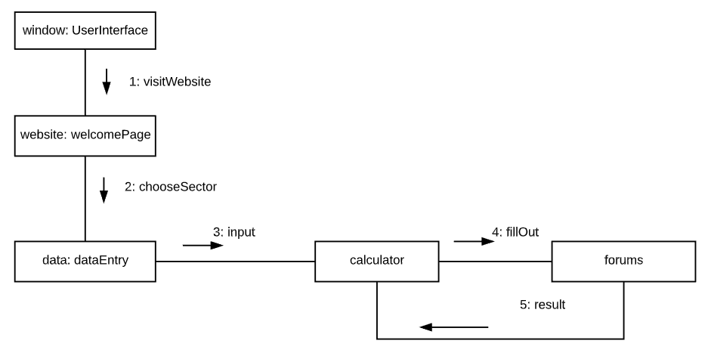

Figure 2: Interactive Diagram

#### 4.2.3 Unit Testing

Unit testing is a level of software testing where individual units/ components of the software are tested. The purpose is to validate that each unit of the software performs as designed. A unit is the smallest testable part of any software. It usually has one or a few inputs and usually a single output.

#### 

#### 

#### 4.2.4 Integration Test.

Integration testing is a level of software testing where individual units are combined and tested as a group. The purpose of this level of testing is to expose faults in the interaction between integrated units. Test drivers and test stubs are used to assist in Integration Testing.

#### 

#### 4.2.5 Wireframes.

Page 1)

This is our page one which is our what’s your product page   
It allows us to choose the sector as well as the product name.

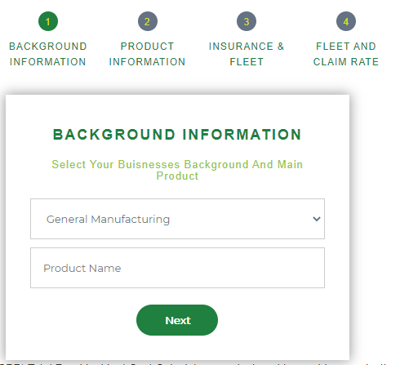

Figure: 3.1 Intro-page Page

This is our page 2 which is more about product name   
It gives us details such as annual sale units  
Return on product  
Gross annual turnover  
And calculated profits

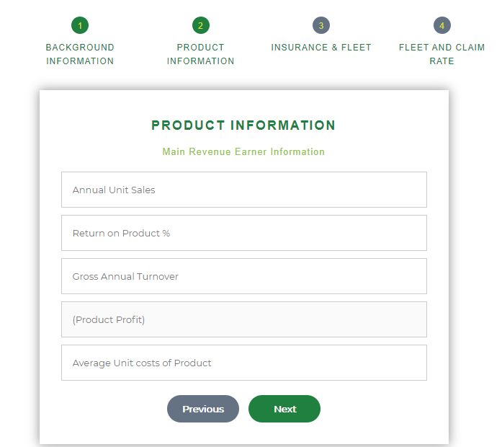

Figure: 4.1 Product Information

Page 3)  
This our page 3 which is about Insurance & fleet information

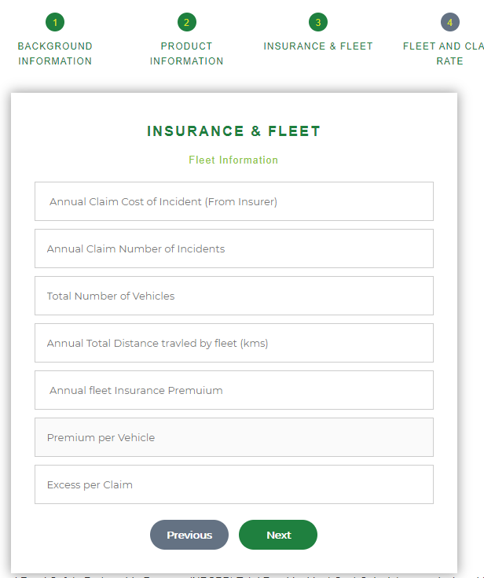

Figure: 5.1 Insurance & Fleet Information

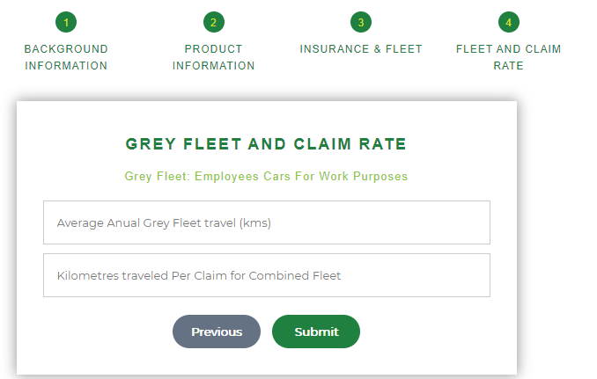

Figure: 5.2 Grey fleet Information

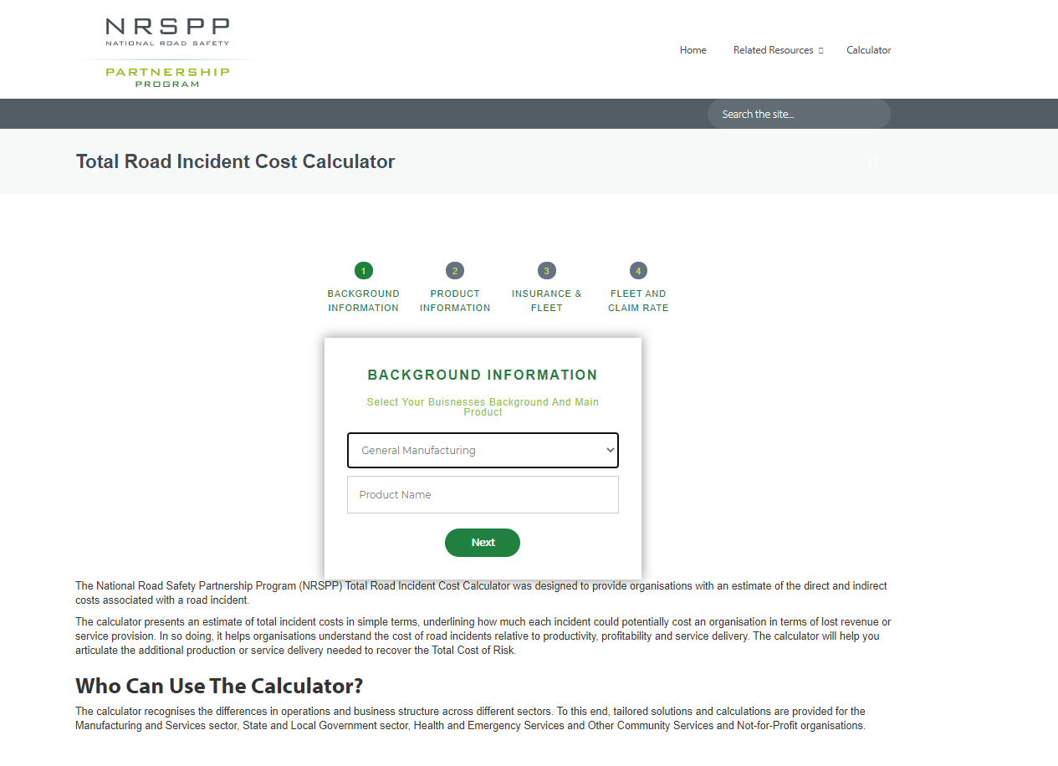

Figure: 6.1 Calculator Page

Changes and modifications done.

The calculator page has gone through constant adaptations   
At the same time receiving client feedback and suggestions.

# 5.0 Object-Oriented Design

### 5.1 High-Level System Architecture

This section breaks down the system architecture into smaller subsections so that they are more easily understood.  
  
The High-level system architecture diagram is a graphical model of the system providing an overview of the system, identifying the main components and their interactions.



Figure 7: System Architecture Diagram

### 5.2 High-Level Package Diagram and Components

Package diagrams in UML are used to structure high-level system elements depicting the dependencies between packages and their interactions

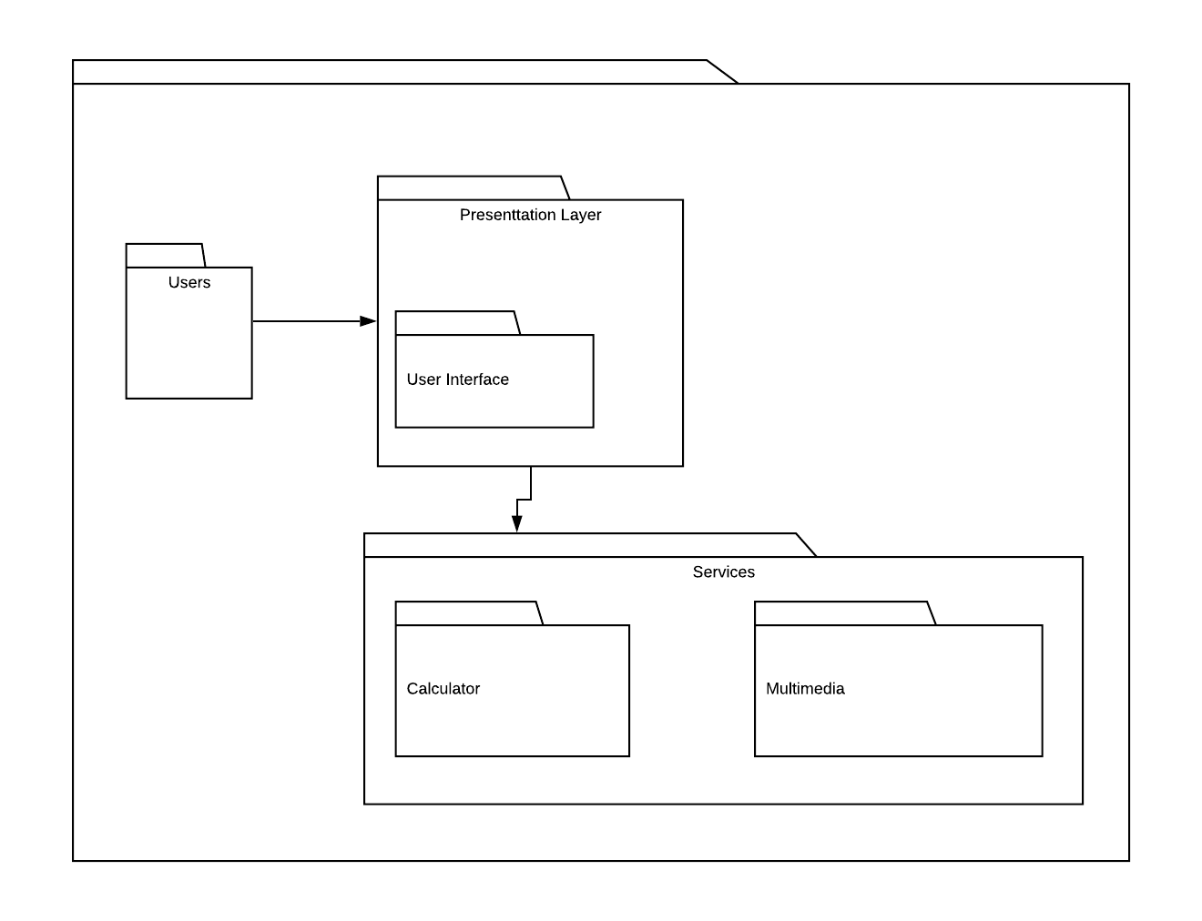

Figure 8: Package Diagram

### 5.3 Use Case Analysis

A Use case diagram is a simple representation of a user’s interaction with the system, portraying different types of users of a system and the various ways they interact with it.   
These diagrams are used along with text-based use cases

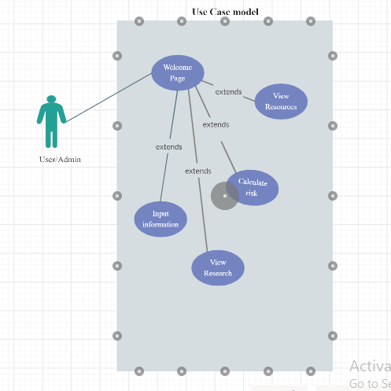

Figure: 9 Use Case Model

#### Use Cases

##### **Use Case 1:** Visit Welcome Page

**Trigger/Goal:** User needs to load welcome page successfully

**Actor:** User

**Main Flow:**

1. The user loads the NRSPP website
2. Welcome page loads successfully.

**Extensions:**

1.a. NRSPP’s website may not load due to some network problems

1. Wait and reload again

2. Inform NRSPP site.

##### **Use Case 2:** Input Information

**Trigger/Goal:** User needs to input all the information in respective fields

**Actor:** User

**Main Flow:**

1.User loads the NRSPP website

2.Welcome page loads successfully.

3.User input all the information in respective fields

4. System accepts all user input

**Extensions:**

1.a. NRSPP’s website may not load due to some network problems

1. Wait and reload again

2. Inform NRSPP site.

3.a. User inputs may be incorrect

1. Correct the input data
2. Reload

##### **Use Case 3:** Calculate Risk

**Trigger/Goal:** User needs to calculate the estimated risk.

**Actor:** User

**Main Flow:**

1.User loads the NRSPP website

2.Welcome page loads successfully.

3.User input all the information in respective fields

4. System accepts all user input

5. User needs to calculate risk

**Extensions:**

1.a. NRSPP’s website may not load due to some network problems

1. Wait and reload again

2. Inform NRSPP site.

3.a. User inputs may be incorrect

1. Correct the input data
2. Reload

##### **Use Case 4:** View Resources

**Trigger/Goal:** The user/admin wants to see the available resources

**Actor:** User

**Main Flow:**

1.The actor selects the resource

2.The actor is redirected to the resource description page with all the contents of the resource.

**Extensions:**

2a - User clicks on the “Back Button” on the browser instead

1. Resource Page terminates.

2. User returns to the session home Page

##### **Use Case 5:** View Research

**Trigger/Goal:** The user/admin wants to see the available research

**Actor:** User

**Main Flow:**

1.The actor selects the research

2.The actor is redirected to the research page with all the contents of the research.

**Extensions:**

2a - User clicks on the “Back Button” on the browser instead

1. Research Page terminates.

2. User returns to the session home Page

### 5.4 Domain Model and Class Diagram

The Domain model is created to represent and identify the relationships between entities within the problem domain.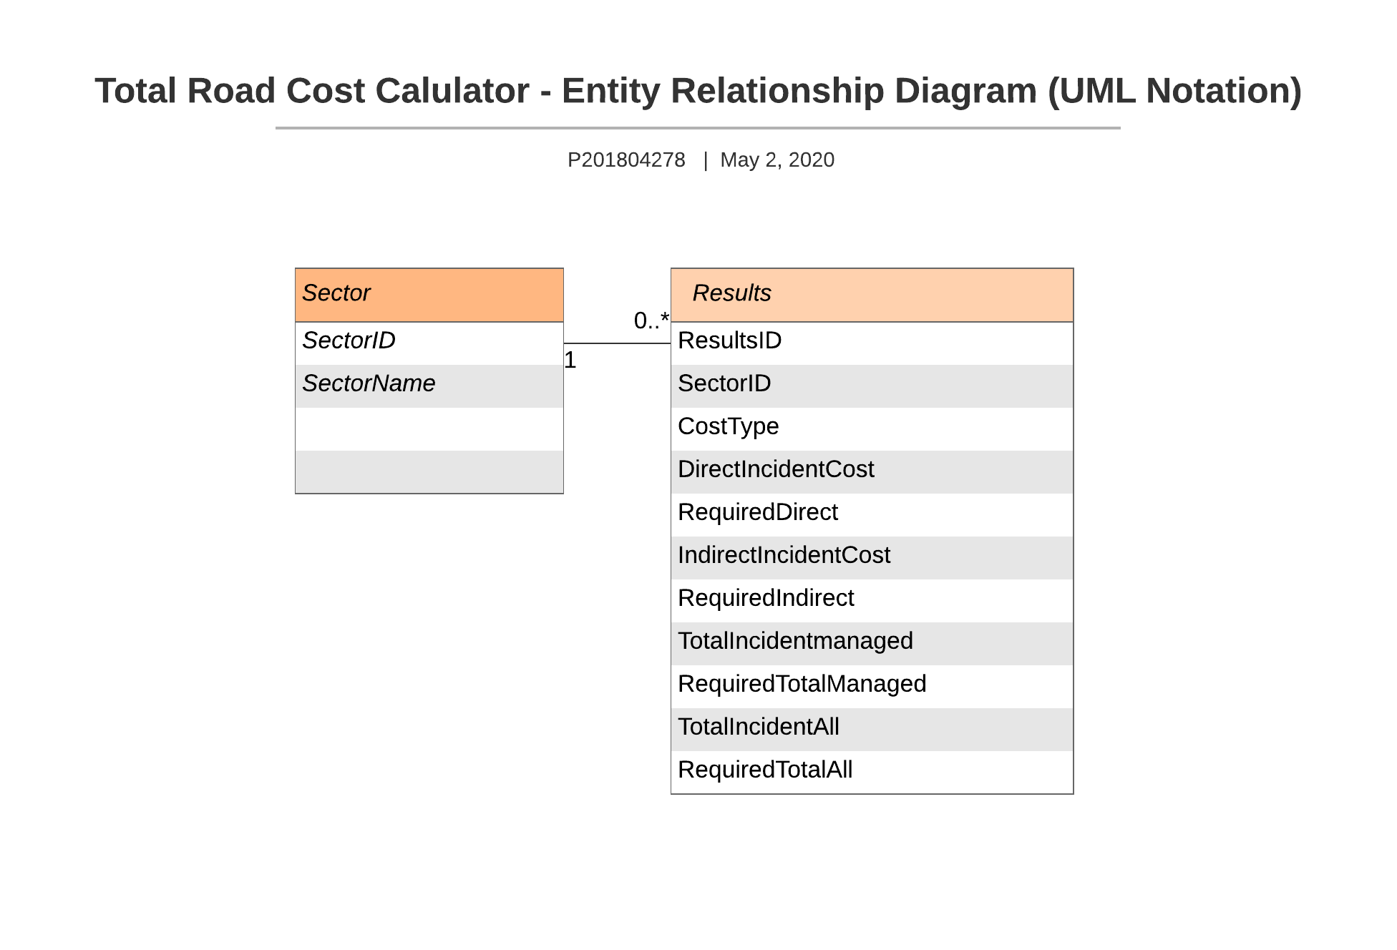

Figure 10: Domain Model

##### **Relational Tables**

**Sector (id,** sectorName)

**Results(id**, sector_ID, costType, directIncidentCost, requiredDirect, indirectIncedentCost, requiredIncident, totalIncedentManaged, requiredTotalManaged, totalIncedentAll, requiredTotalAll**)**

|  |  |  |  |
| --- | --- | --- | --- |
| **Entity** | **Name** | **Null** | **Other Constraints** |
| **Sector** | **ID**  **sectorName** | **NOT NULL**  **NOT NULL** | **PRIMARY KEY** |

|  |  |  |  |
| --- | --- | --- | --- |
| **Entity** | **Name** | **NULL** | **Other Constraints** |
| **Results** | **Id**  sector_ID  costType  directIncidentCost  requiredDirec  indirectIncedentCost  requiredIncidenttotal  IncedentManaged  requiredTotalManaged  totalIncedentAll  requiredTotalAll | **NOT NULL**  **NOT NULL**  **NOT NULL**  **NOT NULL**  **NOT NULL**  **NOT NULL**  **NOT NULL**  **NOT NULL**  **NOT NULL**  **NOT NULL**  **NOT NULL** | **Primary Key**  **Foreign Key**  **reference Results(ID)** |

### 5.5 Establishment of the Database Objects and Data Access Strategy

The domain model is a representation of the vocabulary and concepts of the problem domain.  
The domain model identifies the relationships among the entities within the scope of the problem domain and their attributes

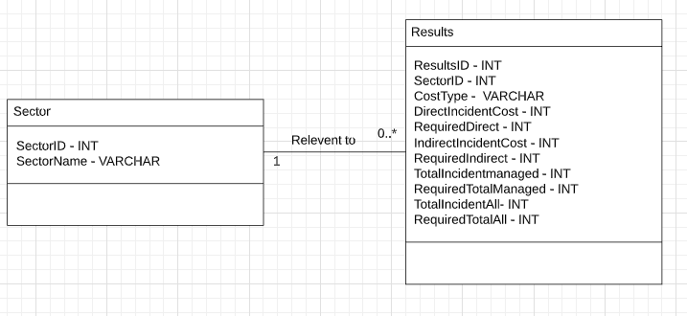

Figure 11 : Class Diagram

### 5.6 Sequence Diagram

A Sequence diagram is an interaction diagram that illustrates how processes operate with one another and in what order.   
  
It is a structured arrangement of messages, showing an object interaction within the system arranged in the time sequence of the messages exchanged between different objects that are needed to carry out the functionality of the scenario.

User -Calculator page Do Loop While Filling Forum Until Complete  
When Completed send information to Server which Runs calculations  
Sending Results to Database and Displaying User results to User.

### 

### 

### Figure: 12 Sequence Diagram

### 

### 5.7 Object Dictionary

Below listed are all the Objects and their methods developed for our Web Service

|  |  |  |  |  |  |
| --- | --- | --- | --- | --- | --- |
| Name | Object | Package | Type | Description | Signature |
| chooseSector() | user | Resource Management | Method | Provides Sector Context form user. | chooseSector() |
| homepage() | user | Resource Management | Method | Represents the | homepage() |
| input() | user | Resource Management | Method | Input user information into the forum | input() |
| forums() | system | Resource Management | Method | Submission of all data to calculator for  calculation | forums() |
| RetrieveDatabase() | system | Resource Management | Method | Returns result from calculator | Retrievedatabase() |

# 6.0 Software release report

### 6.1 Functional Unit Test Report

For usability purposes, we have conducted following tests, getting users to navigate within the web system getting them to review and rate elements of the system

Additionally, there is also a separate usability test performed specifically on the calculator as it is the focal point of our system and the users

The test data is as follows:

Test Cases:

User Test Case: NRSPP’S website can be launched on any devices.

|  |  |  |  |  |
| --- | --- | --- | --- | --- |
| Test Case No.  1 | Test Case Description | Expected Result | Result | Is this result is as expected as expected result?(Yes/No) |
| 1a | Open NSRPP’S website in phone | NSRPP’S website is launched with its homepage at the front. | As expected, | yes |
| 1b | Open NSRPP’S website in tablet | NSRPP’S website is launched with its homepage at the front. | As expected, | yes |
| 1c | Open NSRPP’S website in desktop | NSRPP’S website is launched with its homepage at the front. | As expected, | Yes |

User Test Case: All the webpages in NSRPP’S website can be launched with provided information in it

|  |  |  |  |  |
| --- | --- | --- | --- | --- |
| Test Case No.  2 | Test Case Description | Expected Result | Result | Is this result is as expected as expected result?(Yes/No) |
| 2a | Launch homepage | Homepage is launched with the brief information about NSRPP | As expected, | Yes |
| 2b | Launch research page | Research page is launched with the information regarding the research behind the calculator in it | As expected, | Yes |
| 2c | Launch resources page | Resource page is launched with the resources in it. | Resource page is empty now. | No |
| 2d | Launch calculator | Calculator page launched and asks for the user to input information | As expected, | Yes |

User Test Case: The layout out of old website was tallied with the new one

|  |  |  |  |  |
| --- | --- | --- | --- | --- |
| Test Case No.  3 | Test Case Description | Expected Result | Result | Is this result is as expected as expected result?(Yes/No) |
| 3a | Theme and the colour selection were tallied. | Theme and the colour selection of the website matches with the old website. | As expected, | Yes |
| 3b | Design and layout for indexes were tallied | Design and layout for indexes matched with the old website | As expected, | Yes |
| 3c | Calculator page was tallied | Calculator page matched with the old website | Few moderations were made in new webpage | No |

User Test Case: User could easily navigate to different webpages by selecting it from sub-index

|  |  |  |  |  |
| --- | --- | --- | --- | --- |
| Test Case No.  4 | Test Case Description | Expected Result | Result | Is this result is as expected as expected result?(Yes/No) |
| 4a | User can navigate from home page to other different pages | Selected webpage would launch with respected information | As expected, | yes |
| 4b | User can navigate from different web pages to other different pages and home page | Selected webpage would launch with respected information | As expected, | Yes |

User Test Case: The calculator is user friendly.

|  |  |  |  |  |
| --- | --- | --- | --- | --- |
| Test Case No.  5 | Test Case Description | Expected Result | Result | Is this result is as expected as expected result?(Yes/No) |
| 5a | Users can see what to input in the input field | Input field have transparent index for the expected inputs | As expected, | yes |
| 5b | User can’t submit or go to next page unless all the fields are filled | User won't be able to view another page until the previous page is submitted with the relevant information | As expected, | yes |
| 5c | Easy to input data in input fields | User can easily input data in the input fields | As expected, | Yes |

User Test Case: The calculator functions accordingly to the old calculator

|  |  |  |  |  |
| --- | --- | --- | --- | --- |
| Test Case No.  6 | Test Case Description | Expected Result | Result | Is this result is as expected as expected result?(Yes/No) |
| 6a | Calculator receives to the input data provided | Calculator store and use it for calculation | As expected, | yes |
| 6b | Calculator calculates the total cost from the received data | Calculator should calculate and populate the data | Not yet functional | No |

### 

### 6.2 System Test Report

System testing is performing interactions on the system within a structured pattern with given data, like following a script.

As the system has not been fully implemented yet we have not conducted the testing yet but plan to within the next semester.

A mock-up Test report is as follows.  
As sample data required for the system requires a lot of information, text files may be provided with a full breakdown of information for concurrent testing.

|  |  |  |  |  |  |  |
| --- | --- | --- | --- | --- | --- | --- |
| Test ID | Test Purpose | Steps | Input Parameters | Actual Data Input | Expected Result | Test Status |
| 1.0 | Test calculator functionality | 1. Enter Data Provided 2. Hit Next | “SAMPLE DATA” | “SAMPLE DATA” | The User should get a specific Result breakdown from the calculator | Successful |
| 2.0 | To test if the user can access the resource page | 1. Navigate to the Resource page | N/A | N/A | The User should be able to View Resources | Successful |

# 7.0 Additional User Interface Design

A section dedicated to the additional User Interfaces of the System,

Currently, there are no additional interfaces within the system.

# 8.0 Glossary

**Agile -** It is a software development method based on iterative and incremental development, in which requirements and solutions evolve through collaboration between self-organizing, cross-functional teams

**API** – Application Programming Interface In computer programming, an application programming interface (API) specifies how some software components should interact with each other

**Architectural Diagram -** A graphical representation of all the components of the system, the connections and interfaces between them.

**User Story -** is a concise, written description of a piece of functionality that will be valuable to a user of the software.

**Universal Markup Language - UML** is a general-purpose, developmental, [modelling language](https://en.wikipedia.org/wiki/Modeling_language) in the field of [software engineering](https://en.wikipedia.org/wiki/Software_engineering) that is intended to provide a standard way to visualize the design of a system

# 9.0 Statement of effort

|  |  |  |
| --- | --- | --- |
| **Section** | **Page** | **Members contributed** |
| Table of contents |  | Emey |
| Table of figures |  | Emey |
| 1.1 System Overview |  | Anmol, Emey, Ryan |
| 1.2 Audience Description |  | Anmol, Ryan |
| 1.3 Applicability Statement |  | Anmol, Ryan |
| 1.4 Purpose Statement |  | Anmol, Ryan |
| 1.5 Document Usage Description |  | Connor |
| 2.1 Major Software Functions |  | Connor |
| 2.2 Major Design Constraints and other Requirements |  | Connor |
| 3.1 Existing Software Documentation |  | Connor |
| 3.2 System Documentation |  | Emey |
| 3.3 Vendor Documentation |  | Connor |
| 3.4 Other Documentation |  | Connor |
| 4.0 User Stories |  | Emey |
| 4.1 User Story Dictionary |  | Anmol |
| 4.2 Interactive User Story Documents |  | Ryan |
| 4.2.1 User story definitions |  | Anmol |
| 4.2.2 Flow of interaction testing |  | Emey |
| 4.2.3 Unit testing |  | Emey |
| 4.2.4 Integration testing |  | Emey |
| 4.2.5 Wireframes |  | Ryan |
| 5.1 High-level system Architecture |  | Connor |
| 5.2 Package |  | Connor |
| 5.3 Use Case Analysis |  | Anmol |
| 5.4 Domain model and class diagrams |  | Connor |
| 6.0 - 6.2 Software Testing |  | Connor |
| 7.0 Additional User Interfaces |  | Connor |
| 8.0 Glossary |  | Connor |
| 9.0 Statement of effort |  | Emey |
| Corrections, Grammar and Formatting |  | Connor |